**Lesson - Data Mining from an API**

**Objective**: Students will learn about gathering data from an API and use that information to mine information.

**Vocabulary**:

API - Application Programming Interface

JSON - Javascript Object Notation - syntax for exchanging data

**Warmup** -

Many websites display and gather data.

For example, [activity on Covid-19 infections and deaths.](https://coronavirus.jhu.edu/data/state-timeline/new-deaths/new-york)

Ask students: How do you think they are getting this data?

**Introduction**

Explain what an API- (Application Programming Interface) is.

Show a web site with a free open API:

This web site has a big listing of free, open APIs

<https://github.com/public-apis/public-apis#games--comics>

Have students pick certain categories - click through and show how data is represented, or allow students to spend five minutes clicking through various API sites.

Now look at a COVID-19 API: <https://covidtracking.com/>

After briefly going through the home page, click on “Our Data” and then “Data API”

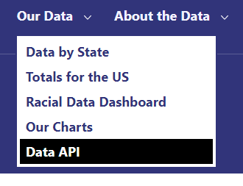

Show the different ways data can be gathered from the API

1. Single State at one time
2. Single State over time
3. Multiple states
4. The US as a whole
5. More

**Task One:**

What URL would you use to find the Total number of Positive Tests and Total Deaths for the state of New York?

<https://covidtracking.com/api/v1/states/ny/current.json>

How many records are shown here? (Answer is just one)

Use that URL to calculate the death rate.

**Task Two:**

How would we find the same data for all of the states?

<https://covidtracking.com/api/v1/states/current.json>

Use that URL to display the Total Number of Positive tests and Total Deaths and death rate for each state.

Which state has the lowest overall death rate?

Which state has the highest overall death rate?

**Task Three:**

List for each week starting with May 3 in New York the total number of deaths for the week

Print out the first day of the week and the total number of deaths for that week.

Which URL would you use?

<https://covidtracking.com/api/v1/states/ny/daily.json>

How would you do this?

**Extensions**

Students can try to find other relationships in the data, looking at changes over time.

They can use the data to integrate with graphic software, making state data clickable from a map.